Team Members: Barrios, Miguel, Kim, Brad, and Guzman, Benedict

7/26/18

Project Proposal: Mass Casualty Incident Triage

Mass Casualty incidents, by definition, is any event wherein the number of personnel and resources of the first responders such as emergency medical services and fire department are outnumbered by the amount and severity of injuries and casualties. MCIs could be caused by events such as motor vehicle accidents, terrorist attacks, and natural disasters such as earthquakes, just to name a few. Perhaps one of the most well-known MCI in recent memory is the 9/11 attack to the twin towers in New York City.

No matter what the cause and the scale of the MCI, first responders follow the protocol called Simple Triage and Rapid Treatment (START). This method was developed in 1983 in Hoag Hospital in California and is used in the United States nationwide. The goal of the START triage is to classify the victims of the MCI into four categories: Green(walking wounded), Yellow(delayed treatment), Red(immediate treatment), and Black(deceased). The START triage follows an algorithm based on different factors such as blood pressure, pulse oximetry, and heart rate. Once the classifications have been determined, treatment of the victims ensue (if necessary).

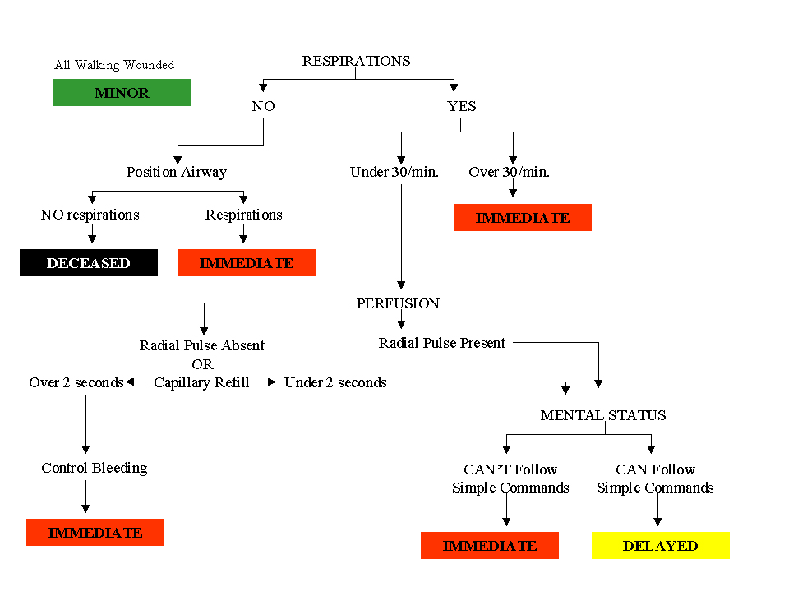

Our goal as a group is to create a python program based on the START triage algorithm. We want this program to be well executed and be reliable if it were to be used by first responders in Mass Casualty Incidents in real life.